PROBLEM STATEMENT

Development of an **TNP web application.**

PROBLEM DESCRIPTION

The project is aimed at developing an online web application for the training and placement department of the college.This system can be used as an application for the TPO of the college to manage the

Student information with regard to placement. Providing Student login helping them to update their personal and educational information in a form which will be added to the database and upload a resume.

PURPOSE

The main purpose of proposed Web based Training and Placement portal is meant to give more easiness to TPO, Placement coordinators and Students that they can modify and access information so quickly. The system provides a better way to maintain students information in the database, ensures data correctness and data integrity as well. The system also reduces the paperwork time.

TECHNOLOGY

1. **MongoDB:** A NoSQL database that stores data in a flexible, JSON-like format called BSON (Binary JSON). MongoDB is known for its scalability and flexibility, making it suitable for handling large amounts of unstructured data.
2. **Express.js:** A web application framework for Node.js that simplifies the process of building robust and scalable web applications. Express.js provides a set of features for web and mobile application development and is often used to create APIs (Application Programming Interfaces) for MERN stack applications.
3. **React:** A JavaScript library for building user interfaces. React is maintained by Facebook and is widely used for creating interactive and dynamic front-end components. It follows a component-based architecture, allowing developers to build reusable UI elements.
4. **Node.js:** A server-side JavaScript runtime that allows developers to build scalable and high-performance network applications. Node.js uses an event-driven, non-blocking I/O model, making it suitable for building real-time applications.

interfaces:

login/signup:

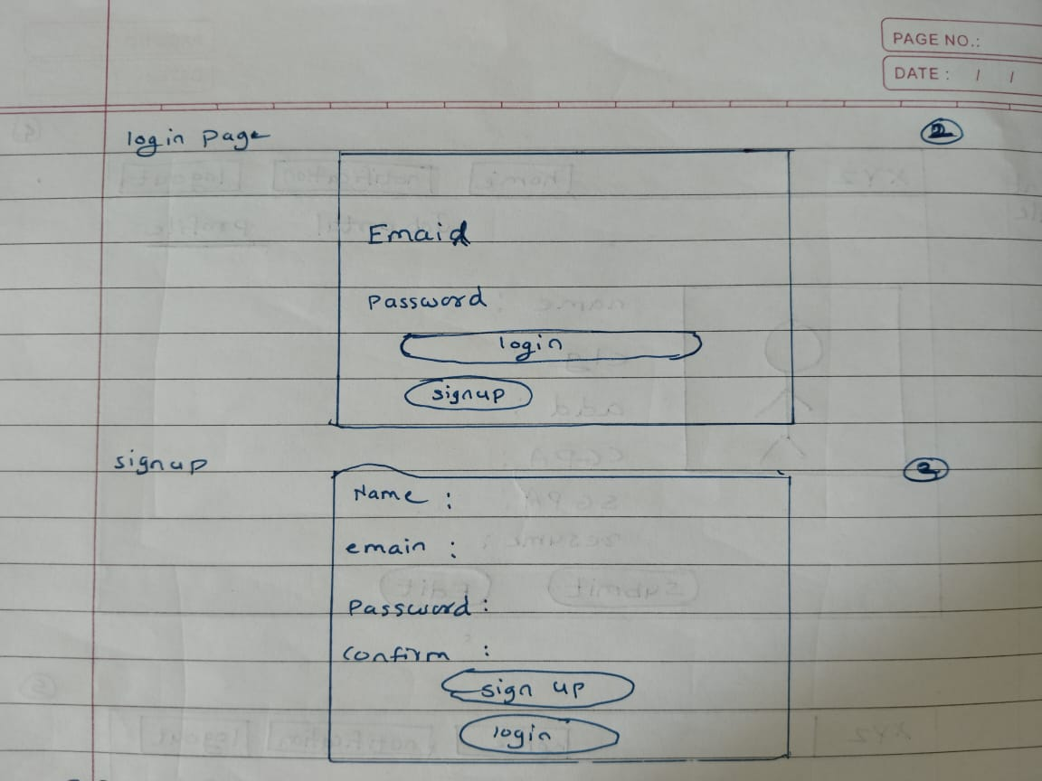

here user will login for account or if user visited our website first time then user should be first create account.

home page:

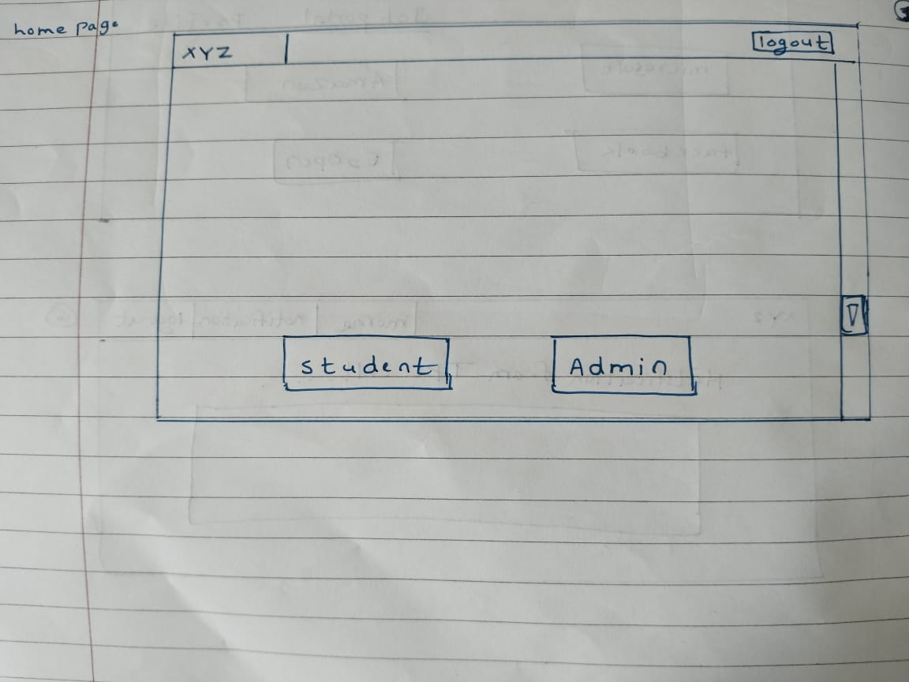

There are two option on home page.

one for student and other for admin.

Student module:

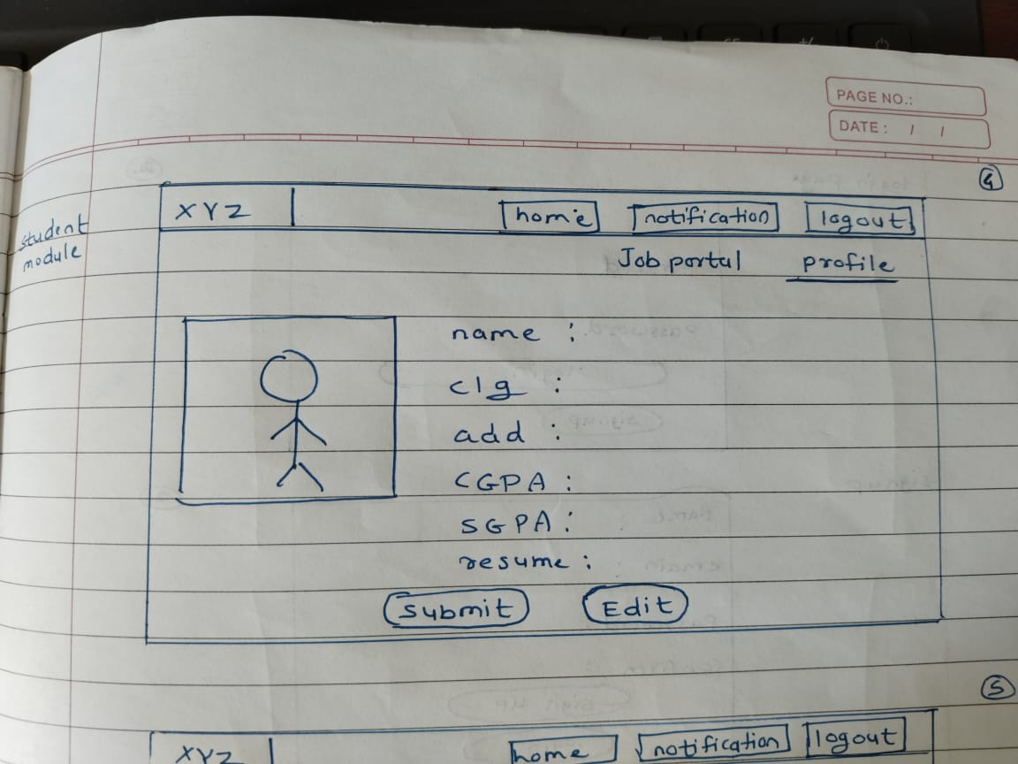

there are two options are there.

one for profile ,in which user can input his required info.and submit it.

Job portal:

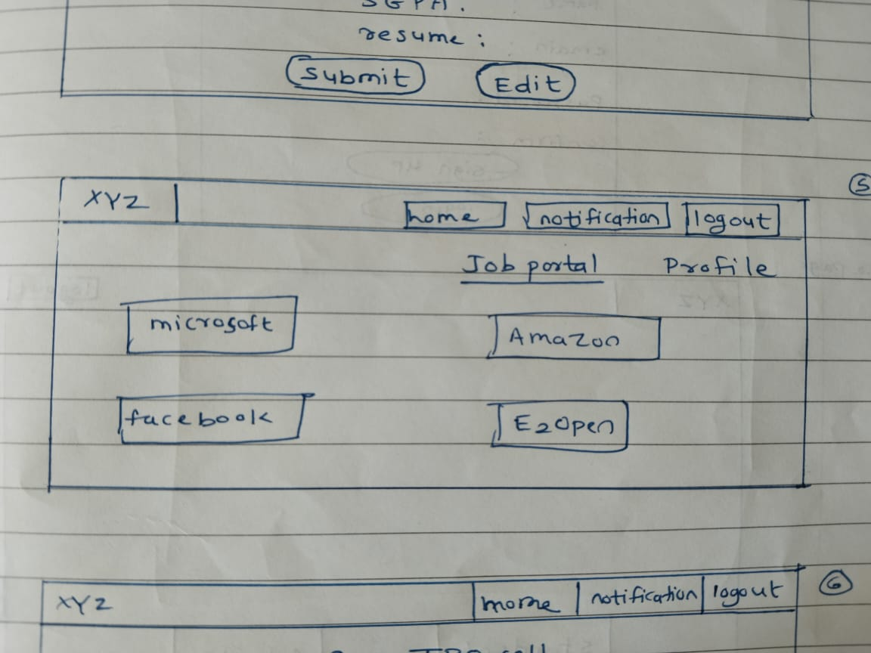

in this page ,all info about placement componies.

Admin module:

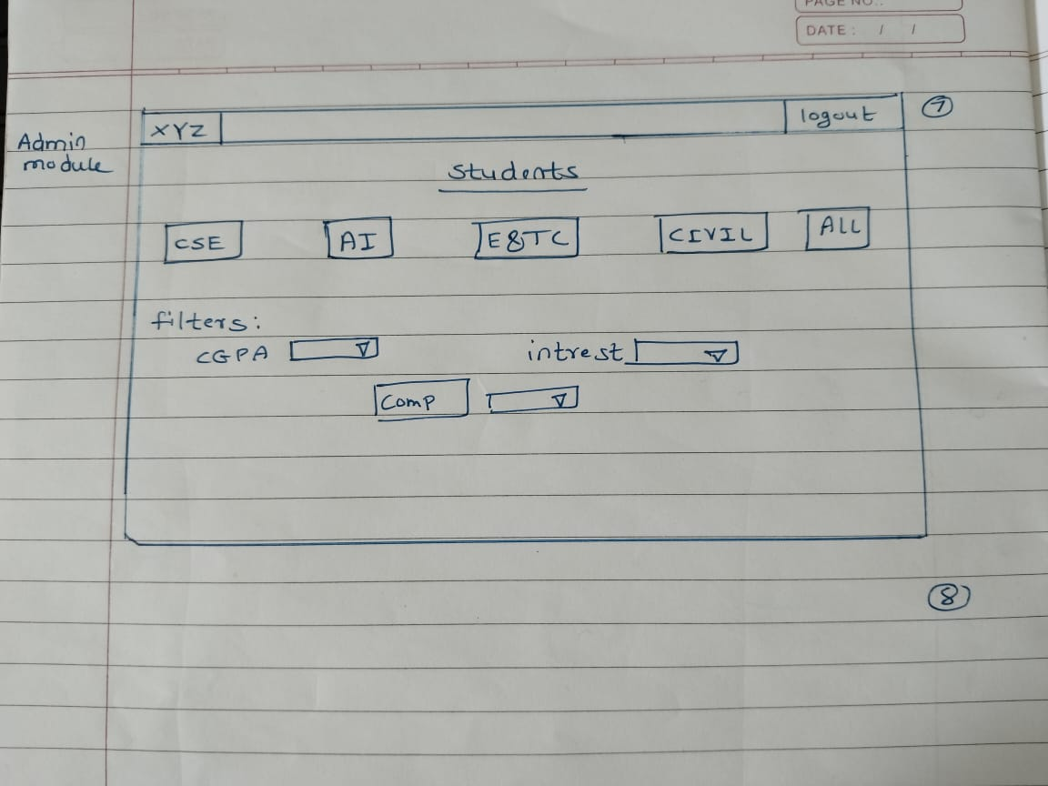

this page is for TPO/admin ,in which admin can filter the data with CGPA,interest,compont vise.